3

**Lab#13(a) Setup a Node.js project on Student Information System**

**Final Outcome:**

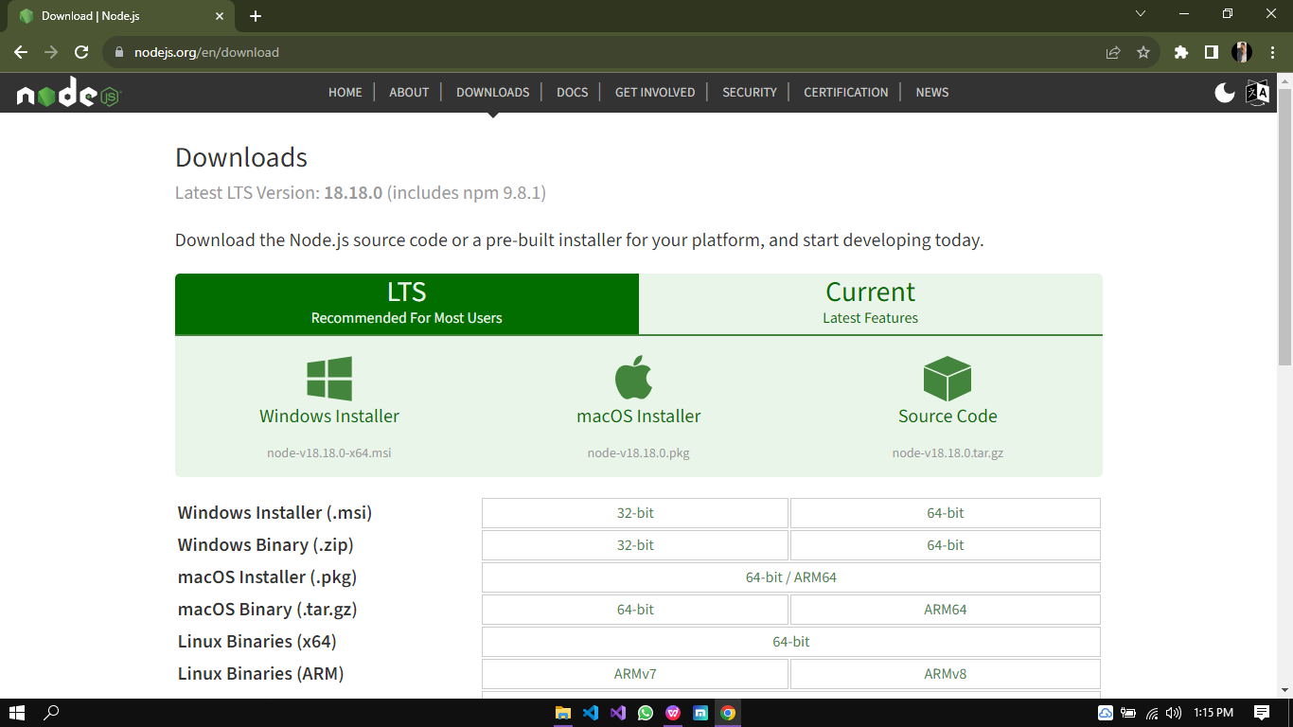

Figure 1 - Downloading Node.js

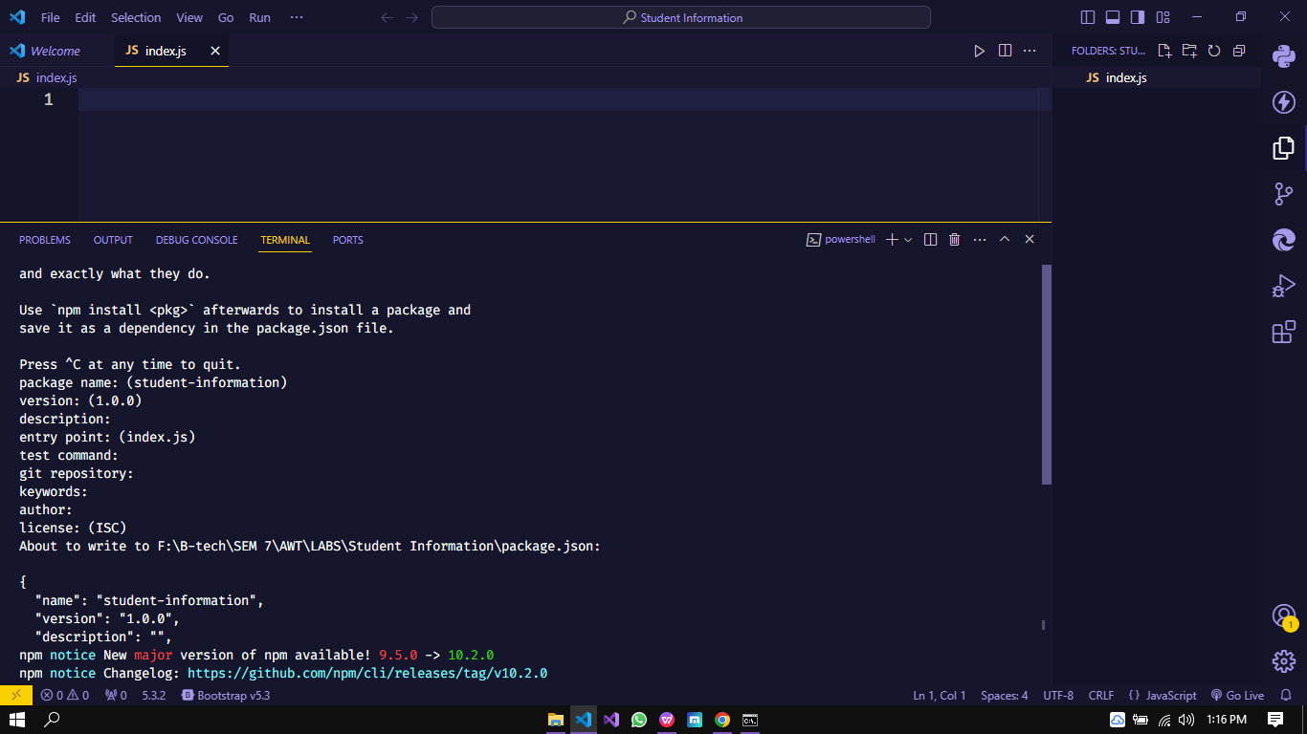

Figure 2 - Creating a folder for index.js file

**Steps:**

1. Download Nodejs from **nodejs.org/eng/download** and install it
2. Create a folder name as “**Student Information**” and create “**Index.js**” file in it.
3. Execute command **“npm init”** to initialize node.js project.
4. Install **mysql** using npm install mysql.
5. Install **express** using npm install express.

**Final Outcome:**

**Lab#13(b) Setup the database in Node.js in Student Information System.**

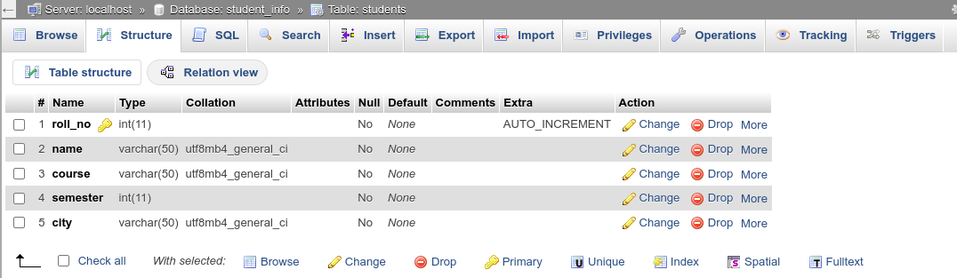

**Code Snippet:**

const mysql = require('mysql')

const express = require('express')

const app = express()

app.use(express.json())

const conn = mysql.createConnection({

host: 'localhost',

user: 'root',

password: '',

database: 'student_info'

})

**Lab#13(c) Implement Select Operation to fetch details of students from Student Information System.**

**Final Outcome:**

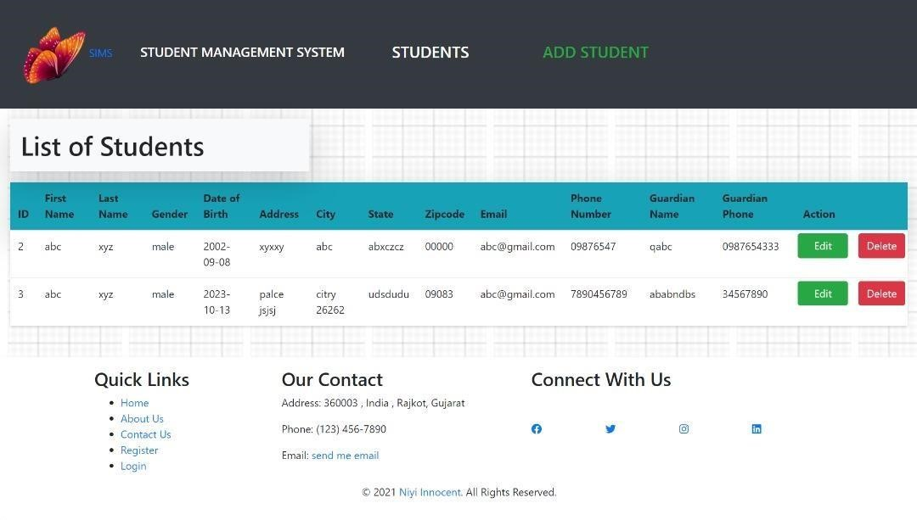

**Code snippet:**

*// Route handler to list all students* exports.listStudents = (req, res) => {

db.all("SELECT * FROM students", (err, students) => { if (err) {

console.error(err); res.status(500).send("Internal Server Error"); return;

}

if (students.length === 0) {

*// Handle the case where no students are found* res.status(404).send("No Students Found"); return;

}